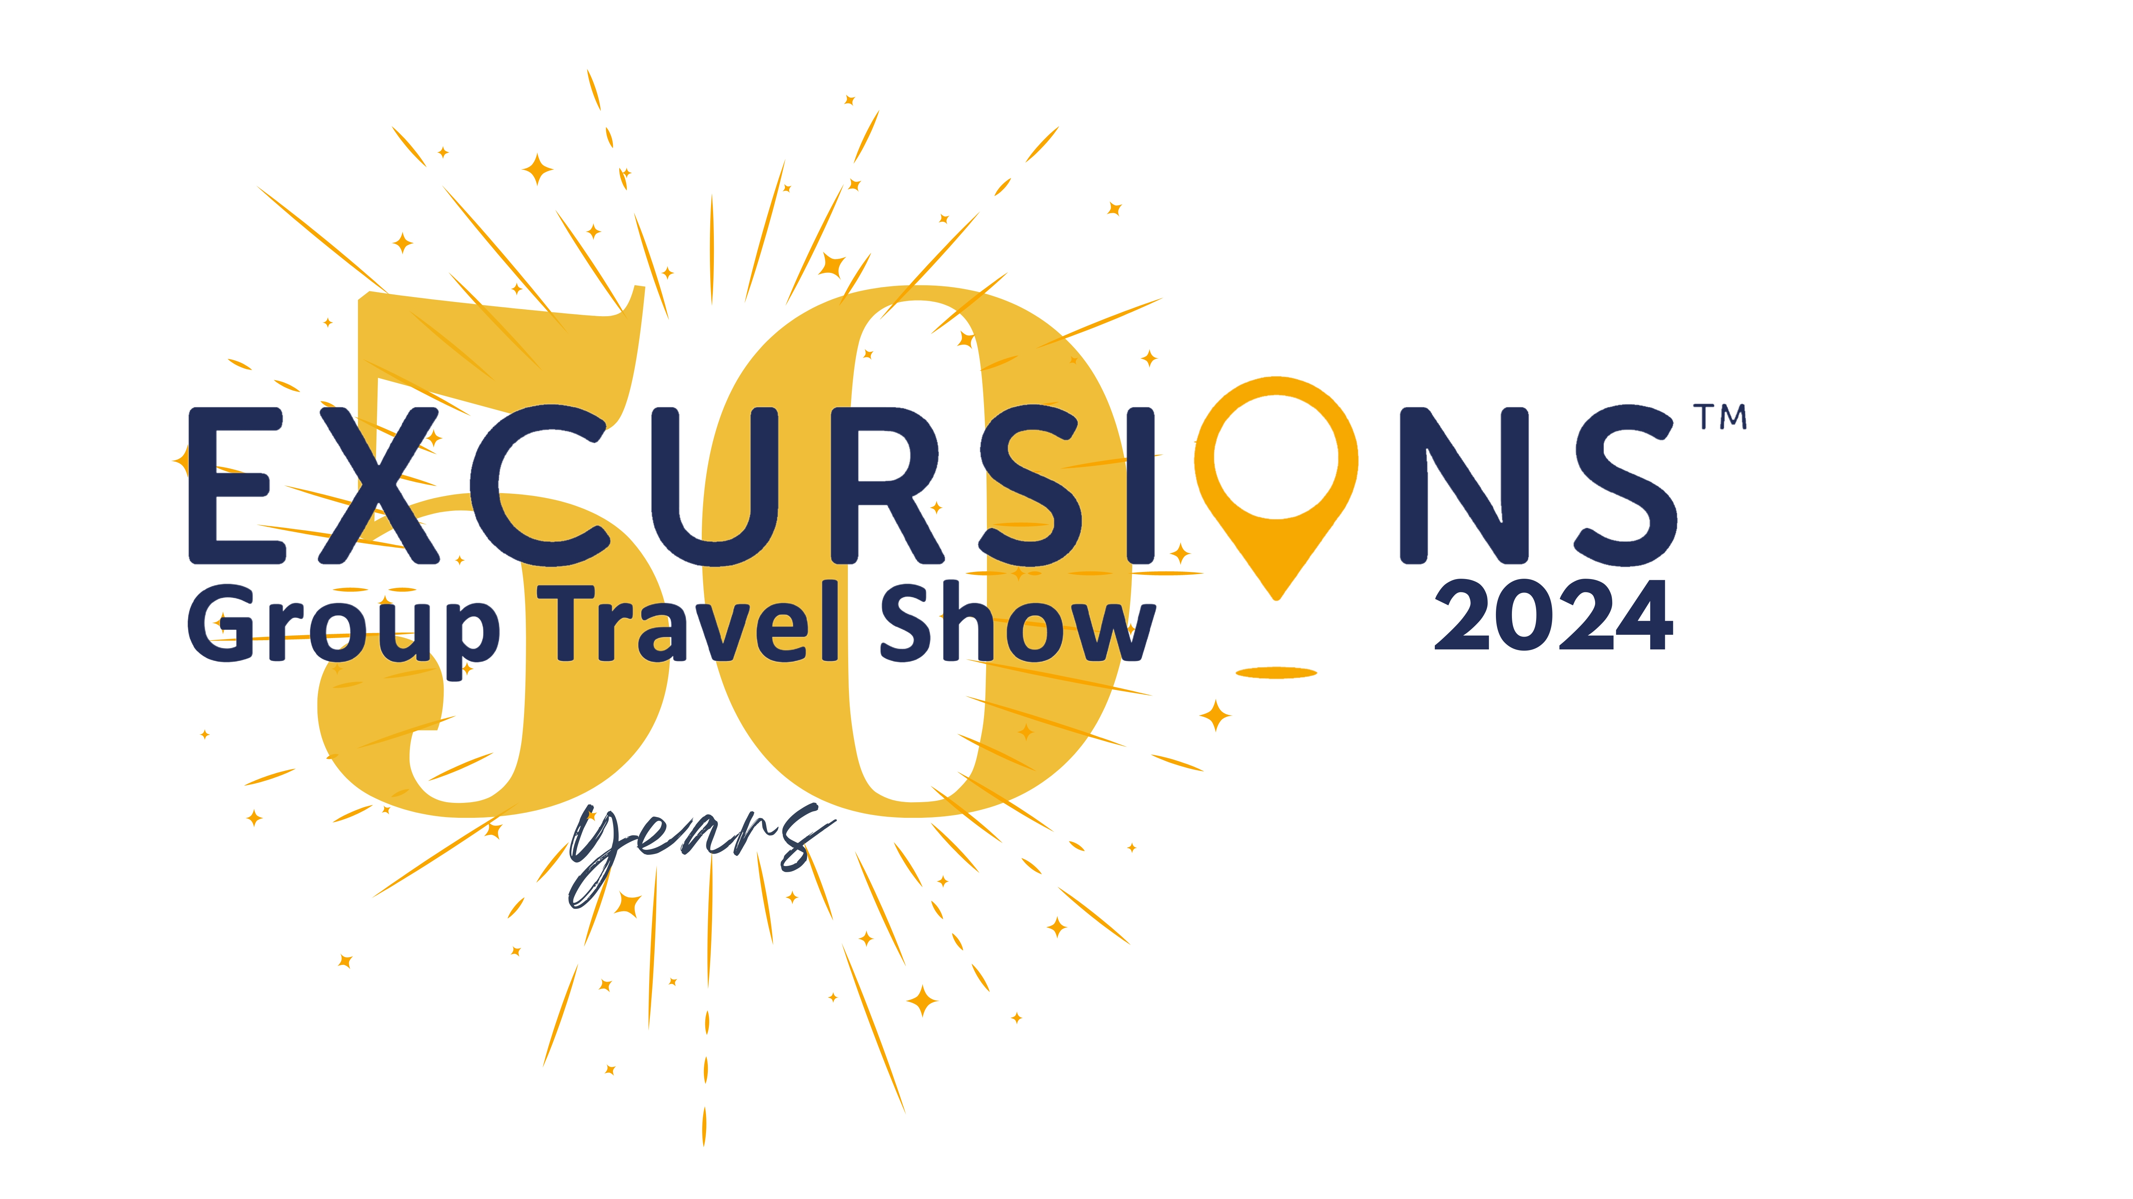

Wednesday 23rd August 2023

Excursions™ and ETOA joins forces to deliver two days of unrivalled

group travel and travel trade networking opportunities.

Excursions™ and ETOA - both driving forces in the group travel and travel trade industries - will team up in 2024 to deliver two days of superb networking opportunities for tourism professionals, enhancing the experience for exhibitors and visitors to both Excursions™ 2024 and Britain and Ireland Marketplace (BIM) 2024.

The collaboration brings together the two leading tourism brands and provides a unique opportunity for tourism businesses to showcase their products to a wider audience, firstly at BIM on Friday 26h January 2024 at InterContinental London – the o2, followed by Excursions™ 2024 on Saturday 27th January 2024 at Wembley Stadium.

ETOA – the European tourism association, a member–driven community working to enable a sustainable business environment in European tourism, is the organisation behind Britain & Ireland Marketplace (BIM), the popular travel trade show promoting British and Irish tourism products to international, European and domestic travel buyers.

Excursions™, which celebrates its 50th anniversary in 2024, is the leading and longest running domestic group show bringing together tourism businesses from the UK and near Europe to meet with domestic GTOs, coach and tour operators and itinerary planners.

Exhibitors attending both shows will also benefit from facilitated logistics between the shows including complimentary transport and discounted accommodation on the Friday evening.

Fran Downton, CEO at Tourism South East who organise Excursions™ commented "We are thrilled to be working with ETOA to present Excursions™ and BIM as complimentary events. This partnership is a great enhancement for the industry and will present a fantastic opportunity to showcase products and collate information across these leading national events.”

Tom Jenkins, CEO of ETOA said “We are delighted to be working with Excursions™. Building on our existing collaboration with VisitBritain and UKinbound, BIM 2024 will host an unrivalled
array of purchasing managers from across the globe. With Excursions, suppliers will now be
able to target the domestic market as well over the two days. It should be an unmissable sales
opportunity.”

For more information about Excursions™ 2024 or to book your stand please visit www.excursionsshow.com Information about Britain & Ireland Marketplace can be found at on the ETOA portal at https://www.etoa.org/

ENDS

Notes

Contact for more information or images:
Rowena Moore
rowenajmoore@gmail.com
02380 625 400

Excursions Show
Excursions is the longest-running and leading domestic group travel show bringing together attractions, destinations, hotels, venues, cruise companies and other tourism businesses with GTOs, coach and tour operators to help them discover group-friendly attractions, plan and book days out and short breaks and to learn of the latest tours, exhibitions and special offers available to groups. Excursions is organised by Tourism South East.

ETOA
ETOA is a member–driven community of over 1,100 organisations, from global brands to independent small businesses, DMOs, industry partners and technical specialists. Supported by our supplier members and partners, we work on behalf of tour operators, wholesalers, destination management companies and agents to enable a sustainable business environment in which European tourism can thrive and grow. Britain & Ireland’s marketplace is one of ETOA’s number B2B events which offer unparalleled networking and contracting opportunities for tourism professionals organising and selling European product in markets around the world.

