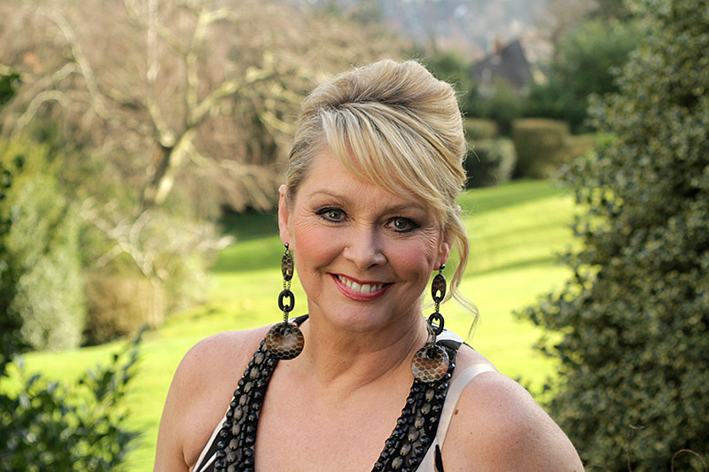

Eurovision Winner, pop star, TV presenter and charitable fundraiser

Cheryl Baker to open Excursions 2024

2024 is a year to celebrate half centuries! Not only does it mark Excursions™ Show’s 50th anniversary and also 50 years since Abba won the Eurovision Song Contest. We're therefore delighted that this year's show opener will pay tribute to both Abba and Eurovision.

Welcoming you to Excursions 2024 at Wembley Stadium will be the Brent Youth Pop Orchestra. And whilst many of the performers were not even born when Abba won the Eurovision Song Contest, such is the legend and hype of both Eurovision and Abba, that every generation sings along to these memorable tunes with gusto and delight. The Brent Youth Pop Orchestra will be performing a medley of some of the best known Eurovision, Abba and pop songs before our special guest officially opens the show. So please be sure to arrive early and join us for this celebratory, top-tapping show opener!

Eurovision Winner, pop star, TV presenter and charitable fundraiser Cheryl Baker will be joining us at Excursions 2024 to present our show opener and officially open our 50th Anniversary Show. Cheryl has twice represented the UK at the Eurovision Song Contest, firstly in 1978 with the band Coco, then going on to win Eurovision in 1981 with the then-named pop group Bucks Fizz. As well as being a household name in the 80s for her successful pop career, she was also being broadcast into households as a TV presenter of popular shows such as Record Breakers. Cheryl helped establish the 'HeadFirst' charity supporting crash victims with head injuries and she continues to fundraise for the charity. She was spurred into action following a serious crash whilst on tour with the group in 1984 in which she broke three vertebrae in her spine and her colleague Mike Nolan suffered serious head injuries,

Pre-registration is now open at https://www.excursionsshow.com/ for free entry to Excursions™ 50th anniversary show, the must-attend Group Travel Show which will take place on Saturday 27th January 2024 at Wembley Stadium.

ENDS

